**Capstone Project Final Assignment**

**Amanda Coady**

**Prof. Alex Aklson**

**June 23, 2020**

**PROJECT DESCRIPTION**

A Newfoundlander who recently moved to Toronto, Ontario is contemplating starting a small business serving traditional Newfoundland food: fish and chips. She has decided that downtown Toronto would be an ideal location of this business venture but first must decide if there is a need for it. Using Foursquare location data she will to determine if this location is going to be as profitable as she hopes.

**INTRODUCTION**

Since the Newfoundlander is not from the Toronto area and has not lived there long, she does not have a lot of market research to base her business start-up on. This could pose as a problem if she does not do the research and compare market data. Using Foursquare data and loading that information into Python, will determine if downtown Toronto is a suitable location for another type of fast food and whether the Newfoundlander will be successful in the fast food industry.

**CONSIDERABLE DATA**

To conduct this research, Python was the sole resource for digesting, processing, and calculating the data. Sources of data were open source and obtained from Wikipedia, the Statistics Canada website – a website administered by the Government of Canada, and Foursquare – a service that collects geographic information regarding all sorts of locations, especially businesses, and user-generated information about the locations such as customer ratings and reviews.

Wikipedia provided a list of postal codes for the city of Toronto; this study hinged on postal codes as the link between the data. Statistics Canada provided population data for the different areas of Toronto, namely the postal codes. Incorporating population data into the postal code data identified the population distribution within the city.

A centroid calculation was run to determine, based on population, where to locate the shop. This was done independent of any information from Foursquare.

Then, Foursquare data was loaded into Python and applied to the problem. A Foursquare search for the term “Newfoundland” was conducted. There were no relevant results.

**METHODOLOGY**

Foursquare credentials were fed into Python. The coordinates for Toronto were found: latitude 43.65 and longitude -79.38 and used them as the focal point for the search of any business containing the word “Newfoundland”. The search results containing “Newfoundland” in it’s title and located “Newfoundland Road” and “The Newfoundland Gift Shop”. There were no fish and chip shops that identified themselves with the province of Newfoundland. Taking into account there is a Newfoundland gift shop catering to the same clients that would patronize “The Newfoundland Gift Shop”.

Instead, a search of the words “Fish and Chips” was conducted. This showed what other fish and chip shops there were in the area. Setting the radius to 5km and setting the result limit to 50, a request was made and received in JSON form. Foursquare returned 50 fish and chip shops centered around the very downtown of Toronto. A dataframe was created from the Foursquare results and stripped all the unnecessary columns from the data leaving the name of the business and its latitude and longitude coordinates.

It was decided to use the fish and chips information to find the best location for the Newfoundland fish and chips shop as it was desirable to be sufficiently far from other shops already established with a clientele. Choosing a location in close proximity to other similar businesses could hurt the start-up as it would have to compete with an already successful business.

The population of Toronto now had to be studied. Wikipedia was used to source each postal code, for the city of Toronto, and its corresponding latitude and longitude. Then, the Stats Canada website was scraped for information concerning all postal codes with the corresponding population; these numbers were calculated during a 2016 census. This information was taken and transformed it into a dataframe. It was then merged with a dataframe of the Wikipedia postal code data. With the location of other competing businesses and the population distribution of the city, it was decided to calculate where the centre (centroid) of the Toronto population was. The calculation resulted in latitude 43.70 and longitude -79.39, which is in Midtown Toronto. Midtown Toronto, according to Wikipedia, is, “...an area of Toronto undergoing a surge in commercial and residential development and a massive influx of young urban professional singles and families.”[1] I believe that the centre of the population of a large area ideal to make my business available to the biggest number of potential customers as possible and the demographics support my belief.

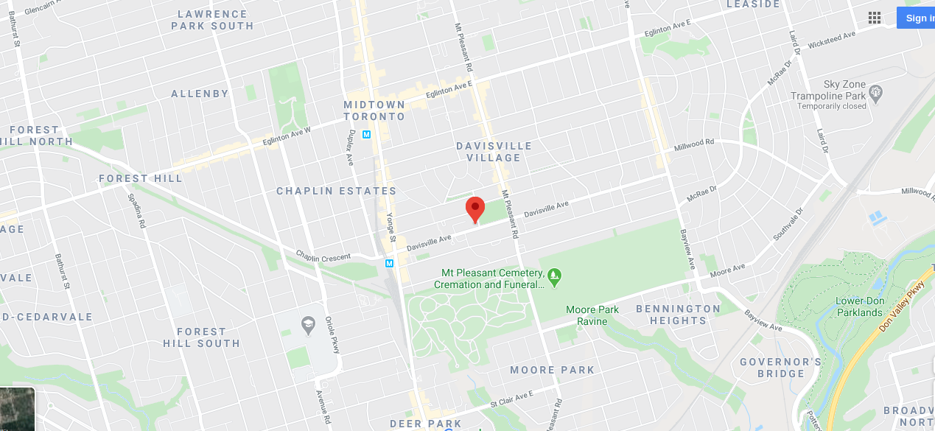Population Centre of Toronto

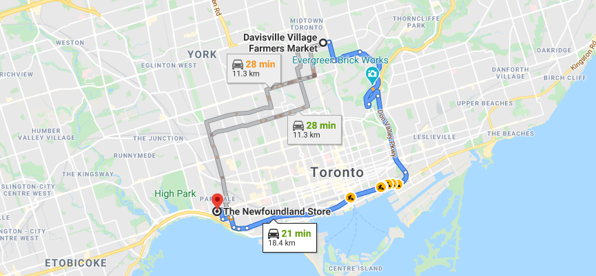The population centre of Toronto is located at latitude 43.70, longitude -79.39, a few blocks away from The Newfoundland Store – the previously found gift shop located at latitude 43.64, longitude -79.44.

Distance of Population Centre to The Newfoundland Gift Shop

Selecting a location further south would bring the prospective business closer to tourist attractions, including the store.

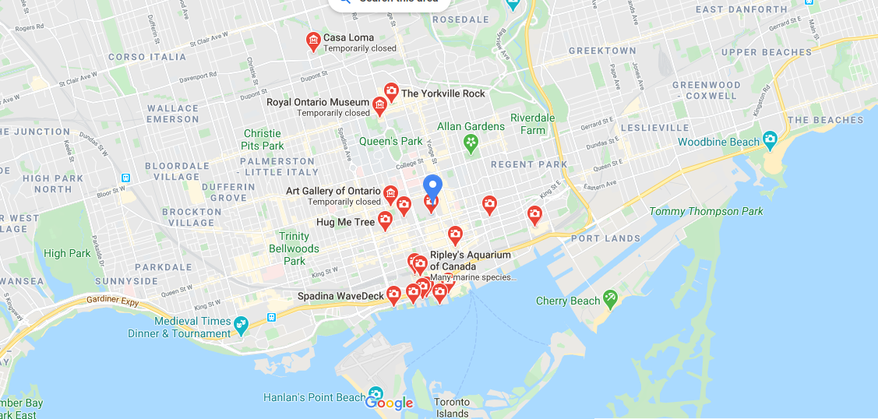Tourist Attractions Around Toronto, Ontario

However, as the target market is Newfoundlanders who find themselves forced away from home, relocating for their career, it would be preferable to select the centre of the population, providing a vast majority of the citizens the easiest possible access.

RESULTS

The results are clear that there is more than one specific location that could do well with a business idea selling traditional Newfoundland fish and chips. The exact location will weigh heavily on the cost of set up, the market for a small property, current restaurants in that area that also serve fish and the availability to get fresh cod to the area of choice. But, of course, the initial discussion must be around if there is a need for it and where it would succeed best.

DISCUSSION

One possible discussion topic would be to open an online discussion about the locals and if there is a “little Newfoundland” community in the Toronto area where several Newfoundlanders have relocated. Major cities seem to have smaller communities within them of individuals from similar backgrounds- does Toronto have one for Newfoundlanders and if so, where might this be? That might change the location of the start-up business if the population base supporting it is in a completely different part of Toronto and not the tourists supporting the business after all.

It also might be advantageous to have a discussion with the owner of The Newfoundland Store about the existing location and whether or not it is ideal for the customer base. Would they relocate to a different location to suit the market better if they were starting up a new business today? Who are their customers: do they mostly have locals from Newfoundland supporting their product line regularly or is it more international tourists looking for something different than just souvenirs of the CN tower in Toronto, Ontario.

Lastly, another idea for discussion might be to suggest the Newfoundlander consider a food cart for the start-up that can relocate at different times of the day or times of the year when some locations may be busier with tourists or locals that will support the need for it. For example, a set up near the Scotiabank Arena during Toronto Maple Leaf hockey games that tend to have a lot of Newfoundland fans would surely do well.

CONCLUSION

In conclusion, there are several factors to consider when choosing a location for a small business that hinges on community support for survival. Taking all factors into consideration before choosing a specific location is the key to its success.

1. https://en.wikipedia.org/wiki/Midtown%2C_Toronto